Sliding Window protocol
AIM: Develop a simple data link layer that performs the flow control using the sliding window protocol,
and loss recovery using the Go-Back-N mechanism.

Description: The essence of all sliding window protocols is that at any instant of time, the sender maintains a set of sequence numbers corresponding to frames it is permit-ted to send. These frames are said to fall within the sending window. Similarly, the receiver also maintains a receiving window corresponding to the set of frames it is permitted to accept. The sender’s window and the receiver’s window need not have the same lower and upper limits or even have the same size. In some protocols they are fixed in size, but in others they can grow or shrink over the course of time as frames are sent and received.
All sliding window protocols, each outbound frame contains a sequence number, ranging from 0 up to some maximum. The maximum is usually 2^{m} − 1 so the sequence number fits exactly in an m-bit field.
Three Sliding window protocol are:
- Stop and wait ARQ ( 1 bit Sliding window)
- Go Back to N
- Selective Repeat ARQ

Stop and Wait ARQ protocol:
- The sender sends a frame and waits for acknowledgment. Once the receiver receives the frame, it sends an acknowledgment frame back to the sender.
- On receiving the acknowledgment frame from the receiver, the sender understands that the receiver is ready to accept the next frame, and then it transmits the next frame
- The stop-and-wait sliding window protocol uses n = 1, restricting the sequence numbers to 0 and 1,
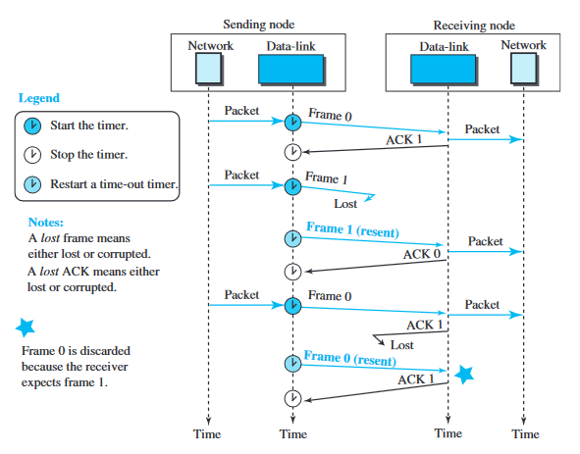
- Go Back to N
The sender window size is 2^{m}-1 and the receiver window size 1.
Sender side
- The number of frames that can be sent at a time totally depends on the size of the sender's window. So, we can say that 'N' is the number of frames that can be sent at a time before receiving the acknowledgment from the receiver..
- Once the transmission buffer is done broadcasting frames, the sender must wait for the acknowledgment.
- If the acknowledgment of a frame is not received within an agreed-upon time period, then all the frames available in the current window will be retransmitted.
- After receiving the acknowledgment, a Go-Back-N sender removes all acknowledged frames from the sending buffer and slides the window to send the next packet in the sequence.
Receiver side
- Only frames that arrive in order are accepted. Any out-of-order frames are discarded.
- If a frame with error is received then the receiver simply discard the frame and all subsequent frames, sending no acknowledgements for the discarded frames. This strategy corresponds to a receive window of size 1.
- It always sends back an acknowledgment after receiving a error free DataFrame that includes the sequence number of the most recent frame it has received.
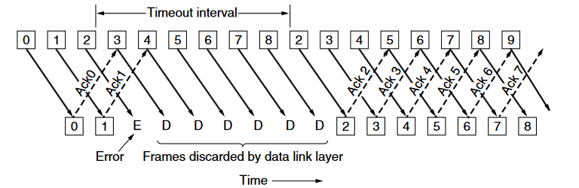
- Selective Repeat
The sender window size is always the same as the receiver window size.
Sender side
- The number of frames that can be sent at a time totally depends on the size of the sender's window. So, we can say that 'N' is the number of frames that can be sent at a time before receiving the acknowledgment from the receiver.
- After the time-out timer expires, the Sender re-transmits the lost frames.
- The sender has to search the lost frames to re-transmit them.
Receiver side
The receiver side sends only independent acknowledgements when it successfully receives packets from the sender instead of cumulative acknowledgments.
Selective repeat is often combined with having the receiver send a negative acknowledgement (NAK) when it detects an error, NAKs stimulate retransmission before the corresponding timer expires and thus improve performance.and receiver accepts out-of-order frames.
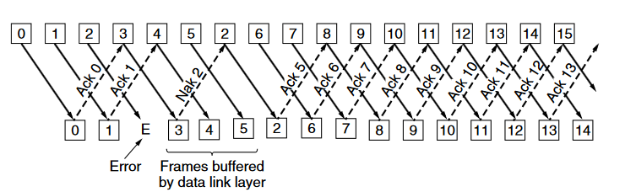
Program:
#include<stdio.h>
void main()
{
int n,frame[100],ack,ch,i;
printf("Enter The Frame size : ");
scanf("%d",&n);
for(i=0;i<n;i++)
{
frame[i]=i+1;
printf("Frame %d sent data : %d\n",i,frame[i]);
}
printf("\nEnter the frame whose acknowledgemet is not recieved : ");
scanf("%d",&ack);
printf("\nEnter 1 for GO Back N\nEnter 2 for Selective Repeat\n");
scanf("%d",&ch);
if(ch==1)
{
printf("\nGO Back N\n");
printf("Frames sent again : \n");
for(int i=ack;i<n;i++)
{
printf("Frame %d sent data : %d\n",i,frame[i]);
}
}
if(ch==2)
{
printf("\nSelective Repeat Protocol\n");
printf("Frame sent again : \n");
printf("Frame %d sent data : %d\n",ack,frame[ack]);
}
}

